Please note enrolment forms WILL NOT BE PROCESSED until your deposit/payment is received.
Payment can be made via bacs/card please call 02891450585 or email us for bank details or paypal to nicholasmartpets@aol.co.uk.
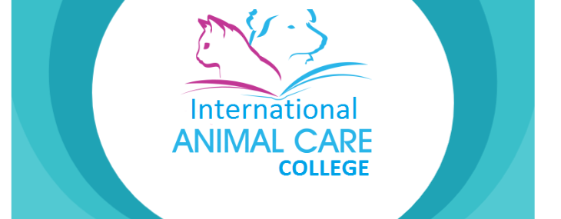ENROLMENT FORM
NAME:
ADDRESS:

POSTCODE:
TELEPHONE:
EMAIL ADDRESS:
DATE OF BIRTH:
Current occupation:
Any learning difficulties:
COURSE YOU WISH TO ENROL ON: | Course Fee:  Deposit enclosed/sent:  Balance:
PREVIOUS EXPERIENCE IF ANY:
Any animal care qualifications:
Reason for attending this course:

How did you hear about us?

BY SIGNING UP TO A COURSE YOU AGREE TO OUR TERMS AND CONDITIONS AS LISTED BELOW AND DECLARE THAT YOU HAVE DISCLOSED ALL REVELANT FACTS:
Full payment is required on online courses at time of booking unless written agreement of payment plan has been given to the student. Courses are non refundable after enrolment.
You have up to 12 months to complete the online course and all assessment. Should you fail to complete the course after this time one extension of 3 months may be given in exceptional circumstances, there will be an administration fee to cover additional tutor time and awarding body and portfolio and admin costs min charge £50 dependant on course.
Please note IACC cannot be held responsible should a course/ certification not be available after 12 months if a student hasn’t completed and all fees will be forfeited.
Please note certifications can take 8-10 weeks however Iacc cannot be held responsible for the length of time it take awarding bodies to send certifications.
By signing up to our courses you are agreeing to the terms and conditions.
Students signature:________________________Date:____

